Week 6 – UML diagram analysis

Daniel Loranger

14-Jun-2025

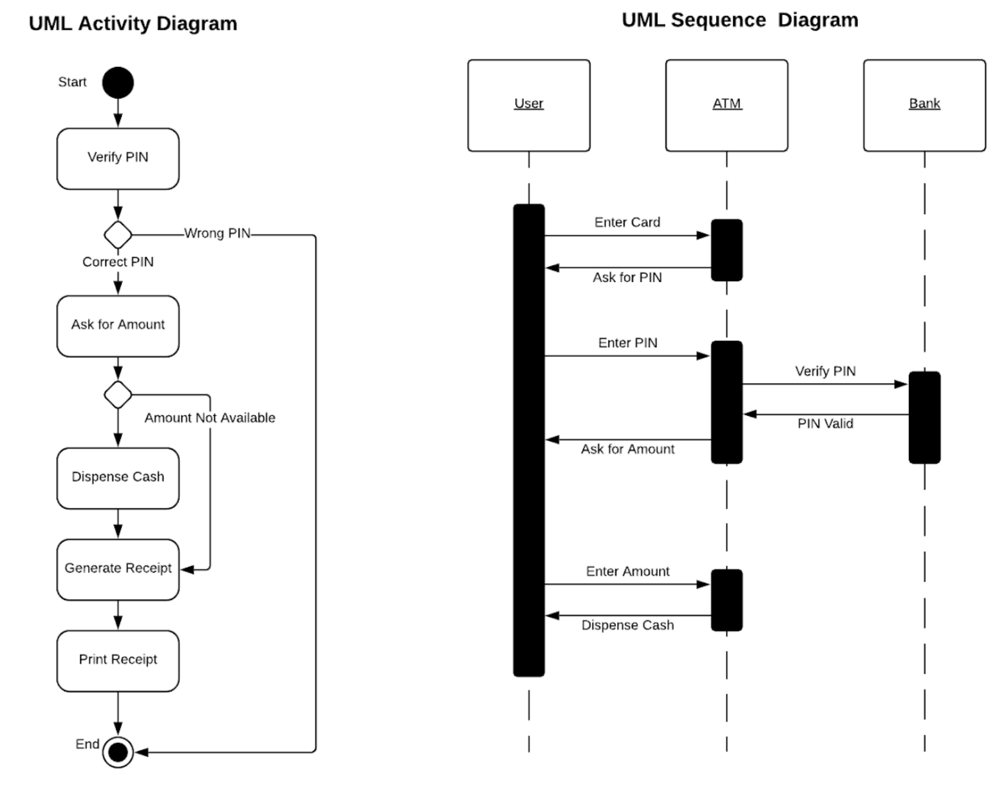

Analysis – Both diagrams show the basic workflows for using an ATM from a user’s perspective. The activity diagram is more familiar as a basic state machine diagram that is useful for showing the states the machine will be in as activities occur in the transaction flow.

The Sequence diagram is less familiar for many readers, but is important and distinct as it shows in a less GUI friendly format the same basic functions, but more importantly for the developers, it shows who is responsible for each activity and the flow of information between the various data sources and actors. This ensures that each separate developer knows what their inputs will be and their expected responses to the inputs. This is important for helping to generate a stateless API on the backend.

In reviewing the two diagrams it is clear that there are discrepancies between the two such as printing the receipt. There is no action for printing in the sequence diagram. Similarly, the enter card action is not captured in the UML diagram.

From a business logic, a point in the sequence diagram that should be improved is verifying the amount of money in the machine and users bank account is sufficient to ensure a user’s requested withdrawal amount can be successfully completed prior to dispensing cash. This is captured in the updated diagram that follows.

An additional portion that could be improved would be to have a retry loop for when a user enters an invalid pin number rather than aborting instantly.

